Install iRedMail on Debian or Ubuntu Linux
- Install iRedMail on Debian or Ubuntu Linux
  - System Requirements
  - Preparations
    - Set a fully qualified domain name (FQDN) hostname on your server
    - Enable default official Debian/Ubuntu apt repositories
    - Download the latest release of iRedMail
  - Start iRedMail installer
  - Screenshots of installation:
  - Important things you MUST know after installation
  - Access webmail and other web applications
  - Get technical support
It's recommended to use the new iRedMail Easy deployment and support platform to deploy and keep your mail server up to date, technical support is available through the ticket system.
Read more: iRedMail Easy - Meet our new deployment and support platform

System Requirements
Warning
- iRedMail is designed to be deployed on a FRESH server system, which means your server does NOT have mail related components installed, e.g. MySQL, OpenLDAP, Postfix, Dovecot, Amavisd, etc. iRedMail will install and configure them for you automatically. Otherwise it may override your existing files/configurations althought it will backup files before modifying, and it may not be working as expected.
- Amazon AWS EC2 blocks port 25 by default, if you plan to deploy mail server with AWS, you need to remove the throttle on port 25.
To install iRedMail on Debian or Ubuntu Linux, you need:
- A FRESH, working Debian/Ubuntu Linux. Supported releases are listed on Download page.
- At least 2 GB memory is required for a low traffic production mail server, but 4 GB is strongly recommended to prevent ClamAV eating too much memory for big virus signature database.
- Make sure 3 UID/GID are not used by other user/group: 2000, 2001, 2002.
Notes:
- All binary packages will be installed from Debian/Ubuntu official apt repositories.
- If you choose Ubuntu Linux, it's recommended to use the latest Ubuntu LTS (Long Term Support) release for production use.

Preparations

Set a fully qualified domain name (FQDN) hostname on your server
No matter your server is a testing machine or production server, it's strongly recommended to set a fully qualified domain name (FQDN) hostname.
Enter command hostname -f to view the current hostname:
$ hostname -f
mx.example.com
On Debian/Ubuntu Linux, hostname is set in two files: /etc/hostname and /etc/hosts.
- /etc/hostname: short hostname, not FQDN.
mx
- /etc/hosts: static table lookup for hostnames. Warning: Please list the FQDN hostname as first item.
# Part of file: /etc/hosts
127.0.0.1 mx.example.com mx localhost localhost.localdomain
sudo hostname mx.example.com
Verify the FQDN hostname. If it wasn't changed after updating above two files, please reboot server to make it work.
$ hostname -f
mx.example.com

Enable default official Debian/Ubuntu apt repositories
- iRedMail needs official Debian/Ubuntu apt repositories, please enable them in /etc/apt/sources.list.
- Install package gzip so that you can uncompress downloaded iRedMail package.
# sudo apt-get install gzip

Download the latest release of iRedMail
- Visit Download page to get the latest stable release of iRedMail.
- Upload iRedMail to your mail server via ftp or scp or whatever method you can use, login to the server to install iRedMail. We assume you uploaded it to /root/iRedMail-x.y.z.tar.gz (replace x.y.z by the real version number).
- Uncompress iRedMail tarball:
# cd /root/
# tar zxf iRedMail-x.y.z.tar.gz

Start iRedMail installer
It's now ready to start iRedMail installer, it will ask you several simple questions, that's all required to setup a full-featured mail server.
# cd /root/iRedMail-x.y.z/
# bash iRedMail.sh

Screenshots of installation:
- Welcome and thanks for your use
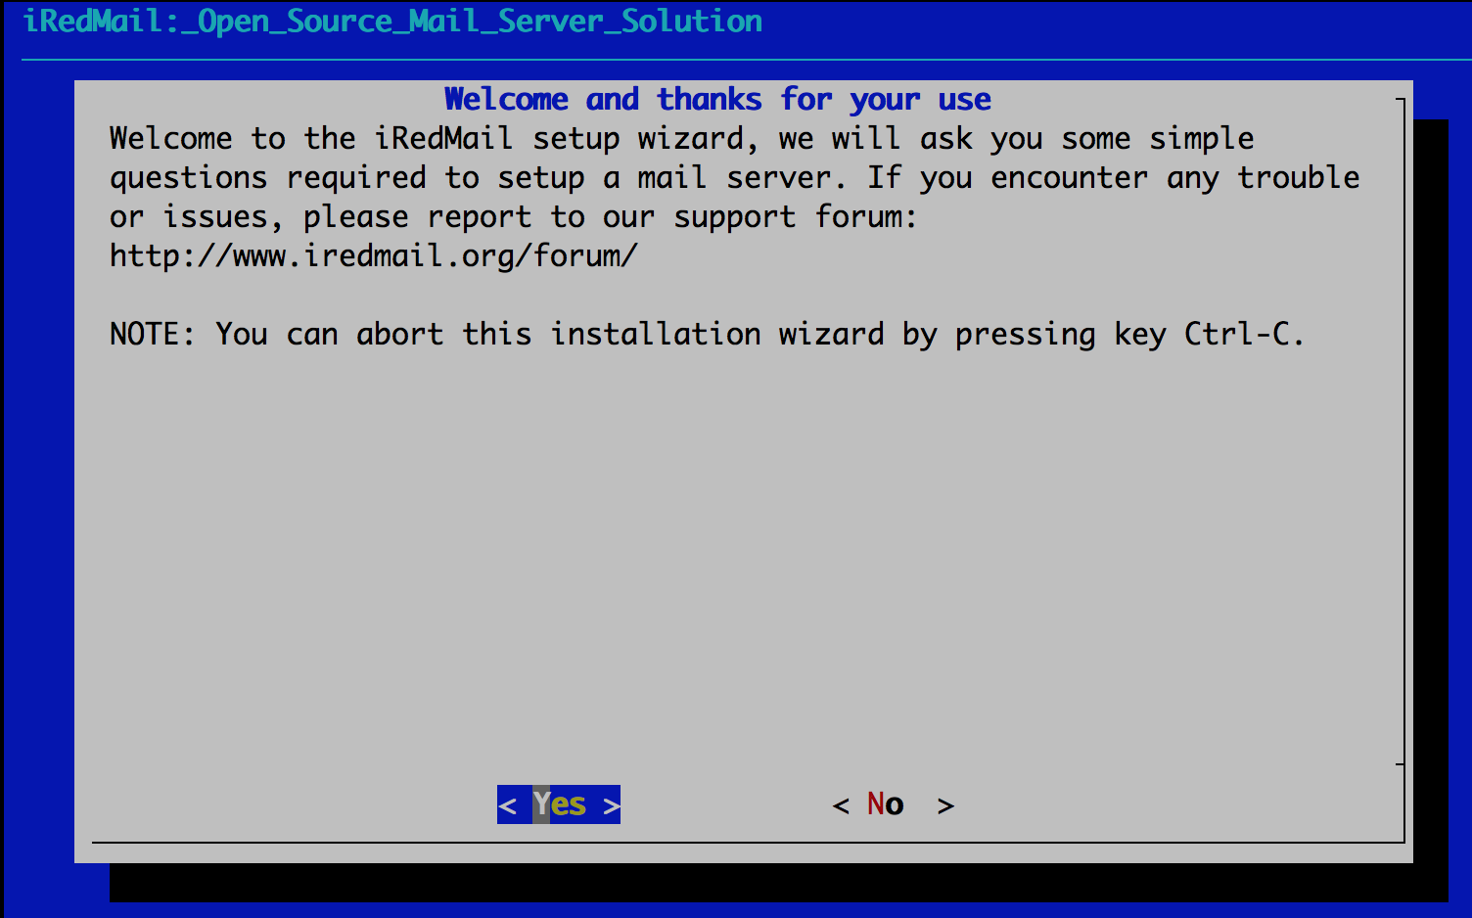
- Specify location to store all mailboxes. Default is /var/vmail/.
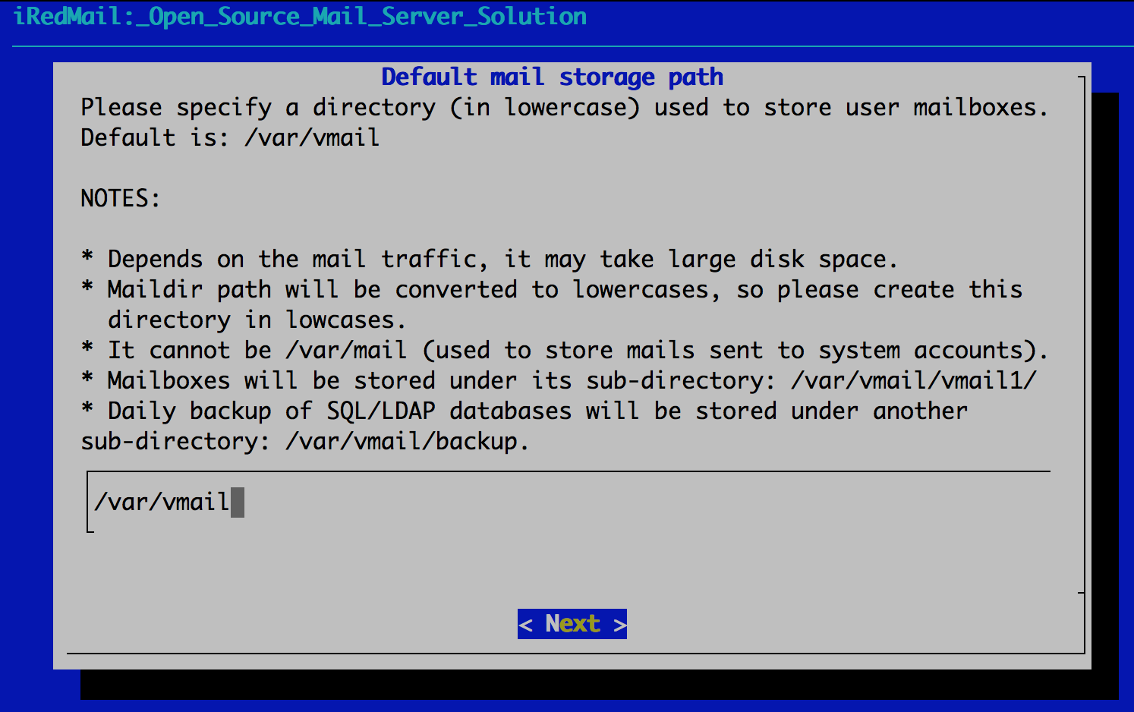
- Choose backend used to store mail accounts. You can manage mail accounts with iRedAdmin, our web-based iRedMail admin panel.
Note
There's no big difference between available backends, so it's strongly recommended to choose the one you're familiar with for easier management and maintenance after installation.
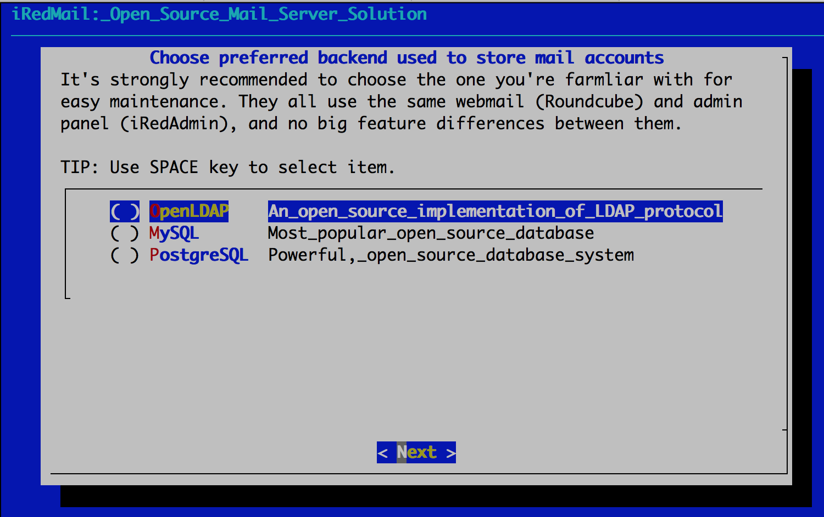
- If you choose to store mail accounts in OpenLDAP, iRedMail installer will ask to set the LDAP suffix.
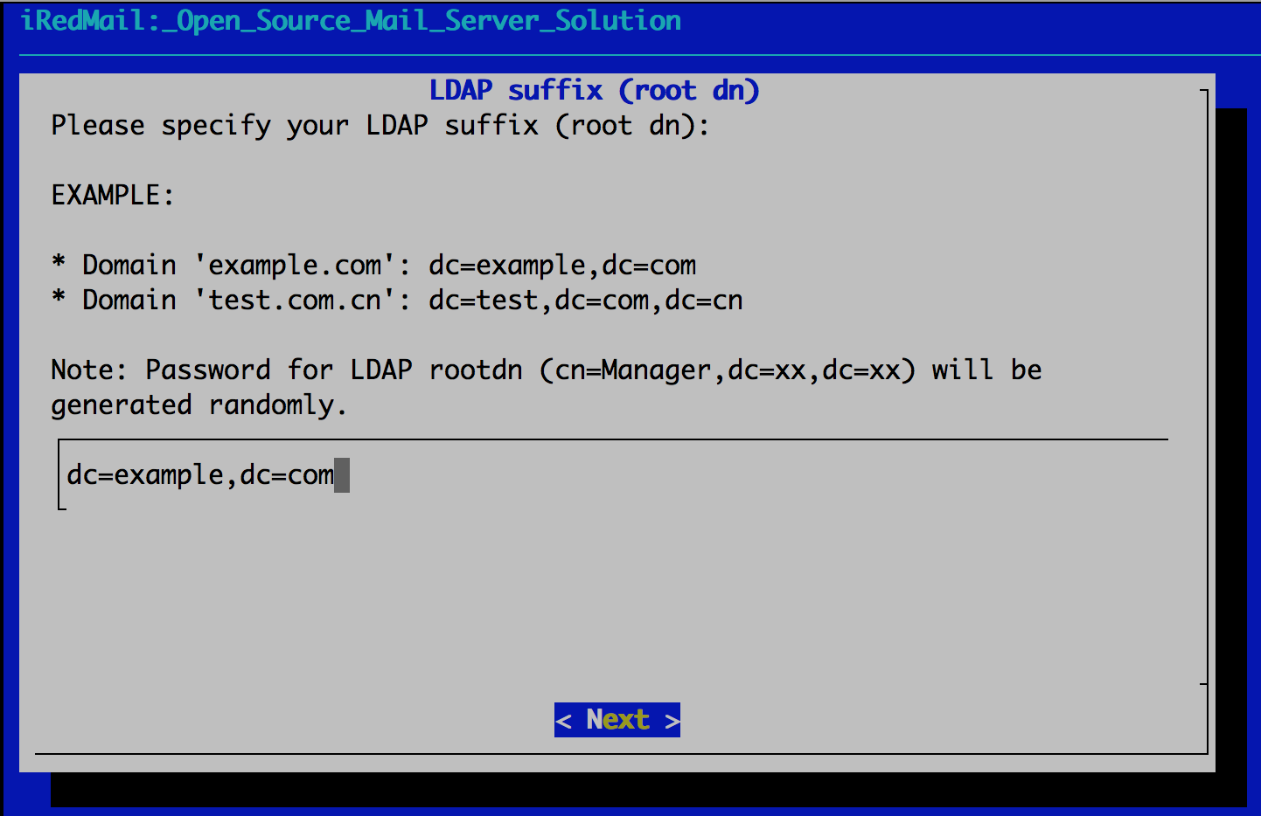
To MySQL/MariaDB/PostgreSQL users
If you choose to store mail accounts in MySQL/MariaDB/PostgreSQL, iRedMail installer will generate a random, strong password for you. You can find it in file iRedMail.tips.
- Add your first mail domain name
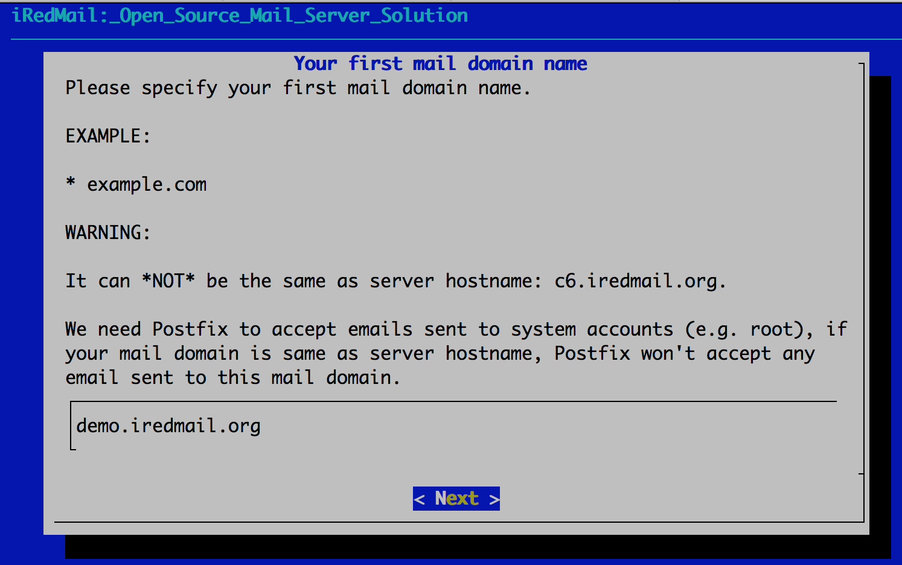
- Set password of admin account of your first mail domain.
Note: This account is an admin account and a mail user. That means you can login to webmail and admin panel (iRedAdmin) with this account, login username is full email address.
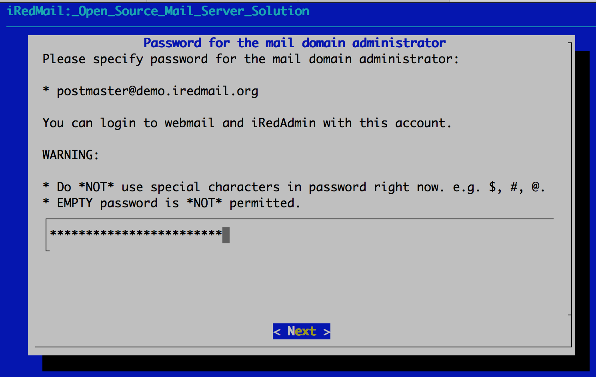
- Choose optional components
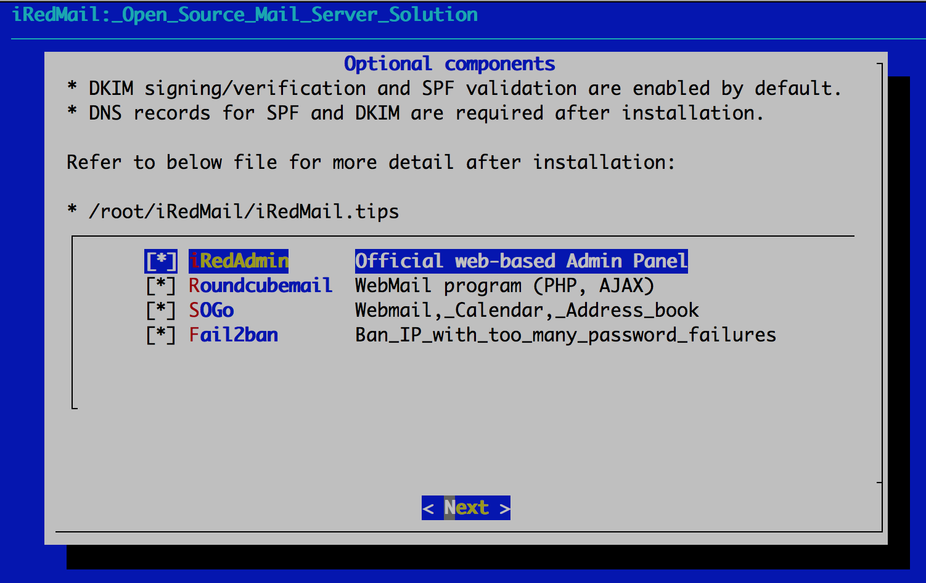
After answered above questions, iRedMail installer will ask you to review and confirm to start installation. It will install and configure required packages automatically. Type y or Y and press Enter to start.
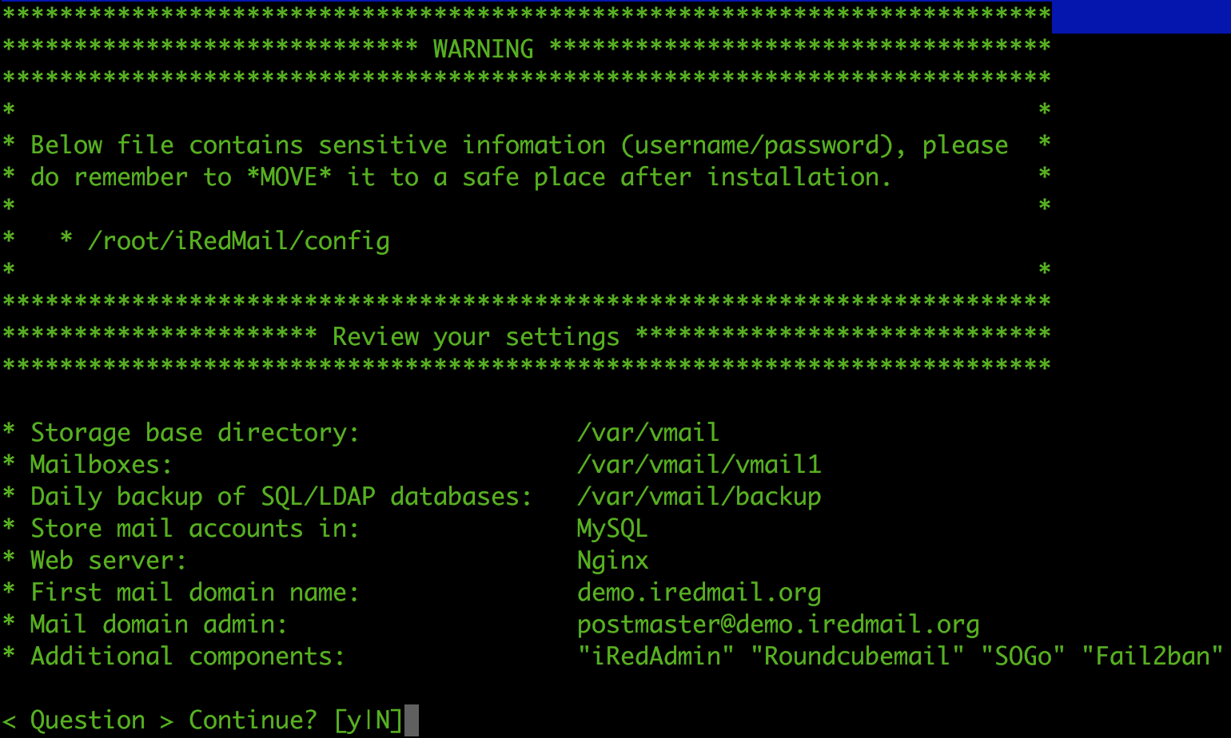

Important things you MUST know after installation
Warning
The weakest part of a mail server is user's weak password. Spammers don't want to hack your server, they just want to send spam from your server. Please ALWAYS ALWAYS ALWAYS force users to use a strong password.
- Read file /root/iRedMail-x.y.z/iRedMail.tips first, it contains:
  - URLs, usernames and passwords of web-based applications
  - Location of mail service related software configuration files. You can also check this tutorial instead: Locations of configuration and log files of major components.
  - Some other important and sensitive information
- Setup DNS records for your mail server
- How to configure your mail clients
- Locations of configuration and log files of major components
- It's highly recommended to get a SSL cert to avoid annonying warning message in web browser or mail clients when accessing mailbox via HTTPS/IMAPS/POP3/SMTPS. Let's Encrypt offers FREE SSL certificate. We have a document for you to use a SSL certificate.
- If you need to bulk create mail users, check our document for OpenLDAP and MySQL/MariaDB/PostgreSQL.
- If you're running a busy mail server, we have some suggestions for better performance.

Access webmail and other web applications
After installation successfully completed, you can access web-based programs if you choose to install them. Replace your_server below by your real server hostname or IP address.
- Roundcube webmail: https://your_server/mail/
- SOGo Groupware: https://your_server/SOGo
- Web admin panel (iRedAdmin): httpS://your_server/iredadmin/
- Awstats: httpS://your_server/awstats/awstats.pl?config=web (or ?config=smtp for SMTP traffic log)

Get technical support
- You are welcome to post issues, feedbacks, feature requests, suggestions in our online support forum, it's more responsive than you expected.
- We offer paid professional support service too, check our web site for more details: Get Professional Support from iRedMail Team.

Sudo nano /etc/hosts
127.0.0.1 mx.ribafslocal.com mx localhost localhost.localdomain

Start iRedMail Configurations
********************************************************************
[ INFO ] Generate self-signed SSL cert (2048 bits, expire in 10 years).
[ INFO ] Generate Diffie Hellman Group with openssl, please wait.
[ INFO ] Create required system accounts.
[ INFO ] Configure Nginx web server.
[ INFO ] Configure PHP.
[ INFO ] Configure MariaDB database server.
[ INFO ] Setup daily cron job to backup SQL databases with /var/vmail/backup/backup_mysql.sh
[ INFO ] Configure Postfix (MTA).
[ INFO ] Configure Dovecot (POP3/IMAP/Managesieve/LMTP/LDA).
[ INFO ] Configure mlmmj (mailing list manager).
[ INFO ] Configure ClamAV (anti-virus toolkit).
[ INFO ] Configure Amavisd-new (interface between MTA and content checkers).
[ INFO ] Configure SpamAssassin (content-based spam filter).
[ INFO ] Configure iRedAPD (postfix policy daemon).
[ INFO ] Configure iRedAdmin (official web-based admin panel).
[ INFO ] Configure Roundcube webmail.
[ INFO ] Configure netdata.
[ INFO ] Configure Fail2ban (authentication failure monitor).

*************************************************************************
* iRedMail-1.0 installation and configuration complete.

